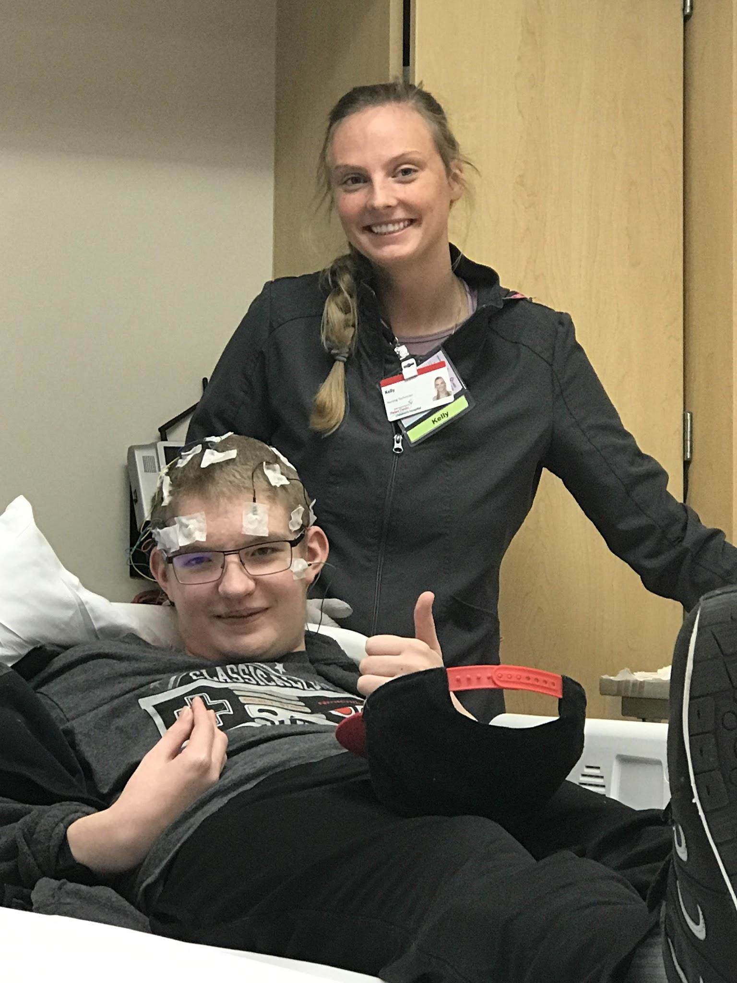
Trip to Grand Rapids
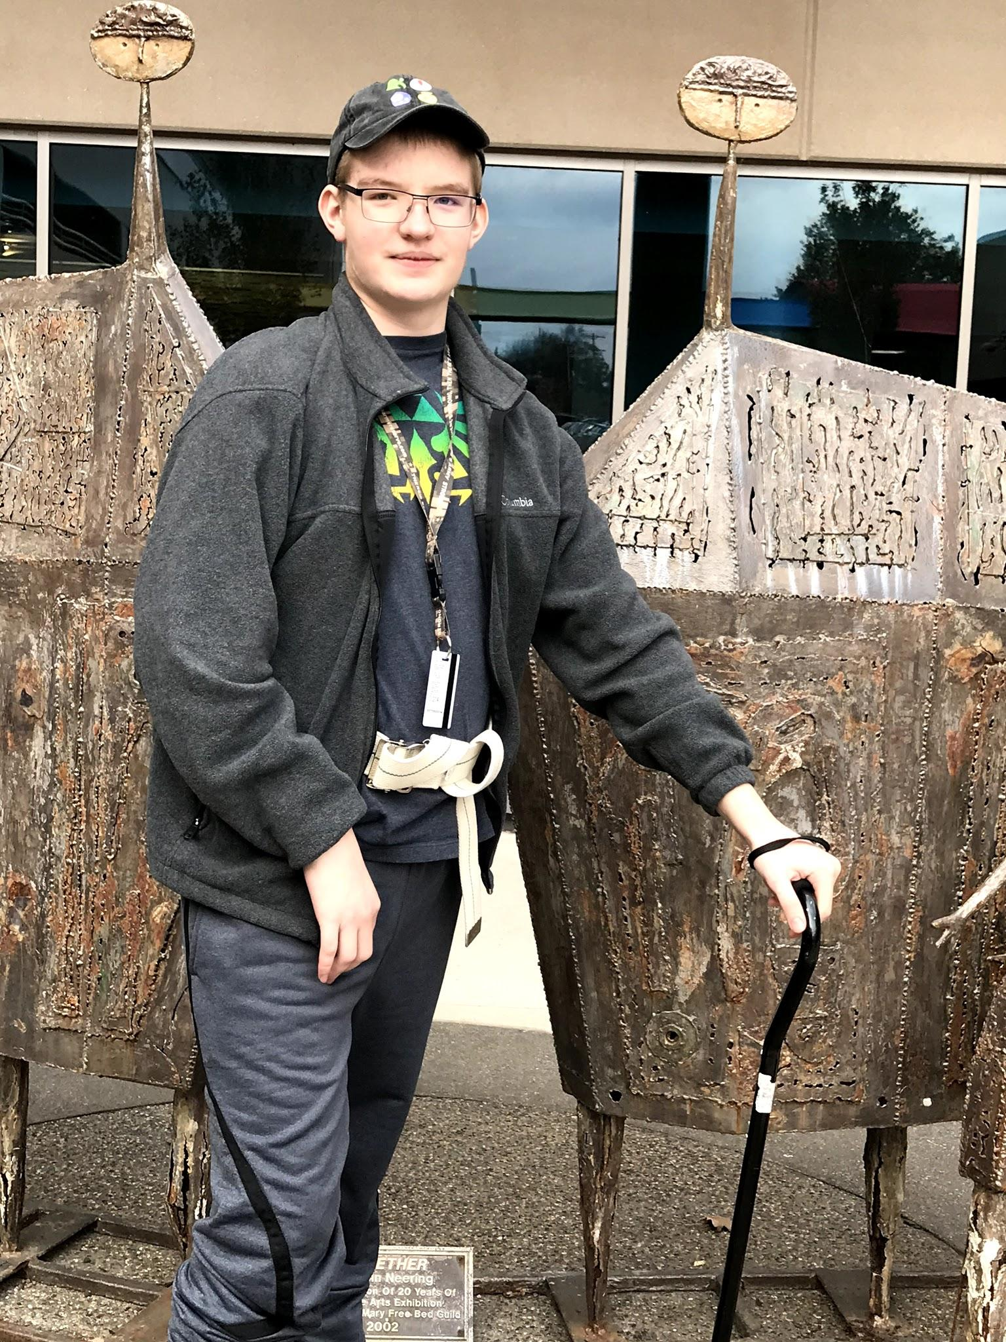

Last week, Josh underwent EEG testing and a follow up appointment with Neurology on Wednesday, and then attended a doctor’s appointment at Mary Free Bed on Friday. In between doctors’ appointments, we stayed at the Hope Lodge in Grand Rapids. We also visited the Woodland Mall on Thursday.
He received many positive remarks from his doctors during his examinations. The nurse practitioner who talked to us in Neurology said that she wasn’t seeing any indications in the EEG that indicates that he is at risk for seizures. He will take anti-seizure medication as a precaution, but things are looking up.
